HADES meeting
September 16, 2021
Present: Martijn, Clair, JPG, Marc, Paul Nagy, Adam, Dani, Kelly Li, Martin Lavallee, Yauheniya Cherkas, Claudia, Ken Wilkins, Fan Bu, Evan Minty, Lee Evans

Clair provided an update on the new CDM version 5.4. Of all proposed changes, only a few are likely to impact HADES:
- A procedure_end_date will be added. This could be used for example in FeatureExtraction when considering when a procedure took place in a particular time window.
- Most fields in cdm_source will be made mandatory. This means we can use these when running a study to capture metadata about the CDM. Marc notes that some data sites have more than one row in cdm_source, and HADES will need to be able to deal with that
- A procedure_status_concept_id field will be added (e.g. indicating primary or secondary diagnosis), which is separate from procedure_type_concept_id (e.g. indicating inpatient or outpatient claims). This will be import for the FeatureExtraction features that are restricted to inpatient diagnoses. (ACTION) Martijn will create an issue for FeatureExtraction.
Marc and Martijn noted that there currently is a hard requirement in HADES packages that concept IDs stay within 32-bit integer range (meaning: smaller than 2^31 = 2,147,483,648). (ACTION) Clair will make sure this documented and checked by DQD.

Martijn initiates a discussion about HADES’ place in the OHDSI toolstack, and the interfaces it has with other components such as ATLAS and ARACHNE.
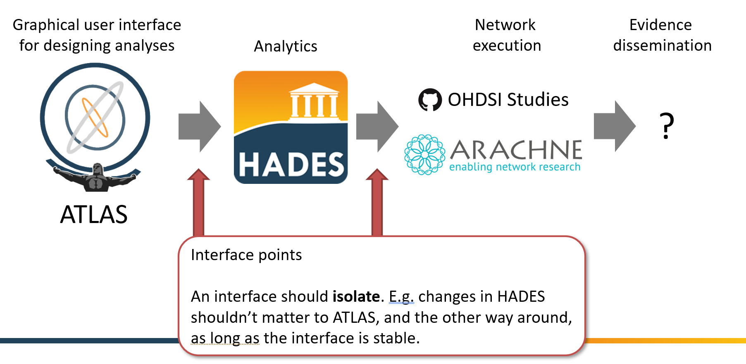

In the next HADES meeting we’ll talk more about nailing down these interfaces. To ensure synchronization between the various components, we propose a quarterly release of Hydra, that can then be integrated in ATLAS and ARACHNE.
Our main mode for study packages that are sent for network execution is using renv to capture all dependencies. This might not work well for everybody, so in addition to these we will also explore (Docker) containers. (ACTION) Adam and Lee will explore writing a script that, given a study package with renv.lock file, will create a Docker container.

